Texas A&M Disc Golf Club Website

**Team Royal Flush**

Andrew Cramer

Alok Chandrawal

Chandler Ochs

Prathiksha Prasad

Snehasish Sen

Vignesh Babu Gandudi

**Team Roles**

Scrum Master: Prathiksha Prasad

Product Owner: Chandler Ochs

**Customer Meeting**

Date: Monday, September 28th

Time: 12pm-12:30pm (Zoom)

**Summary**

The disc golf club is one among the several student organizations at Texas A&M University. The objective of the club is to grow the sport of disc golf, host intra club tournaments as well as competitive tournaments against other clubs and universities. The aim of this project is to build a website as a single point of information about the disc golf club and provide a platform for interested students to get involved.

On a high level, the website will include details about upcoming competitive events, officers in the club, point of contact, local courses, and membership information including pricing. The primary stakeholder is an officer in the disc golf club.

**User stories**

1. Feature: Upcoming Events List

As an event creator

So that I keep members up to date with upcoming events

I want to have a list of upcoming events on the landing page

1. Feature: Social Media Links

As a club officer

So that I can keep members up to date with upcoming events

I want to have links to all social media pages on the landing page

1. Feature: Photo Gallery

As a club officer

So that I can attract new members

I want to have a gallery of recent photos from club activities on the landing page

1. Feature: ‘About Us’ section of the Landing Page

As a club officer

So that I can inform potential members

I want to have an ‘about us’ section on the landing page, that describes the club in detail.

1. Tech: Product Architecture

As a stakeholder

So that I have a stable website

I want to have a list of tools and platforms best suitable for the application

**User Interface**

The image below is the UI discussed in the meeting with our customer.

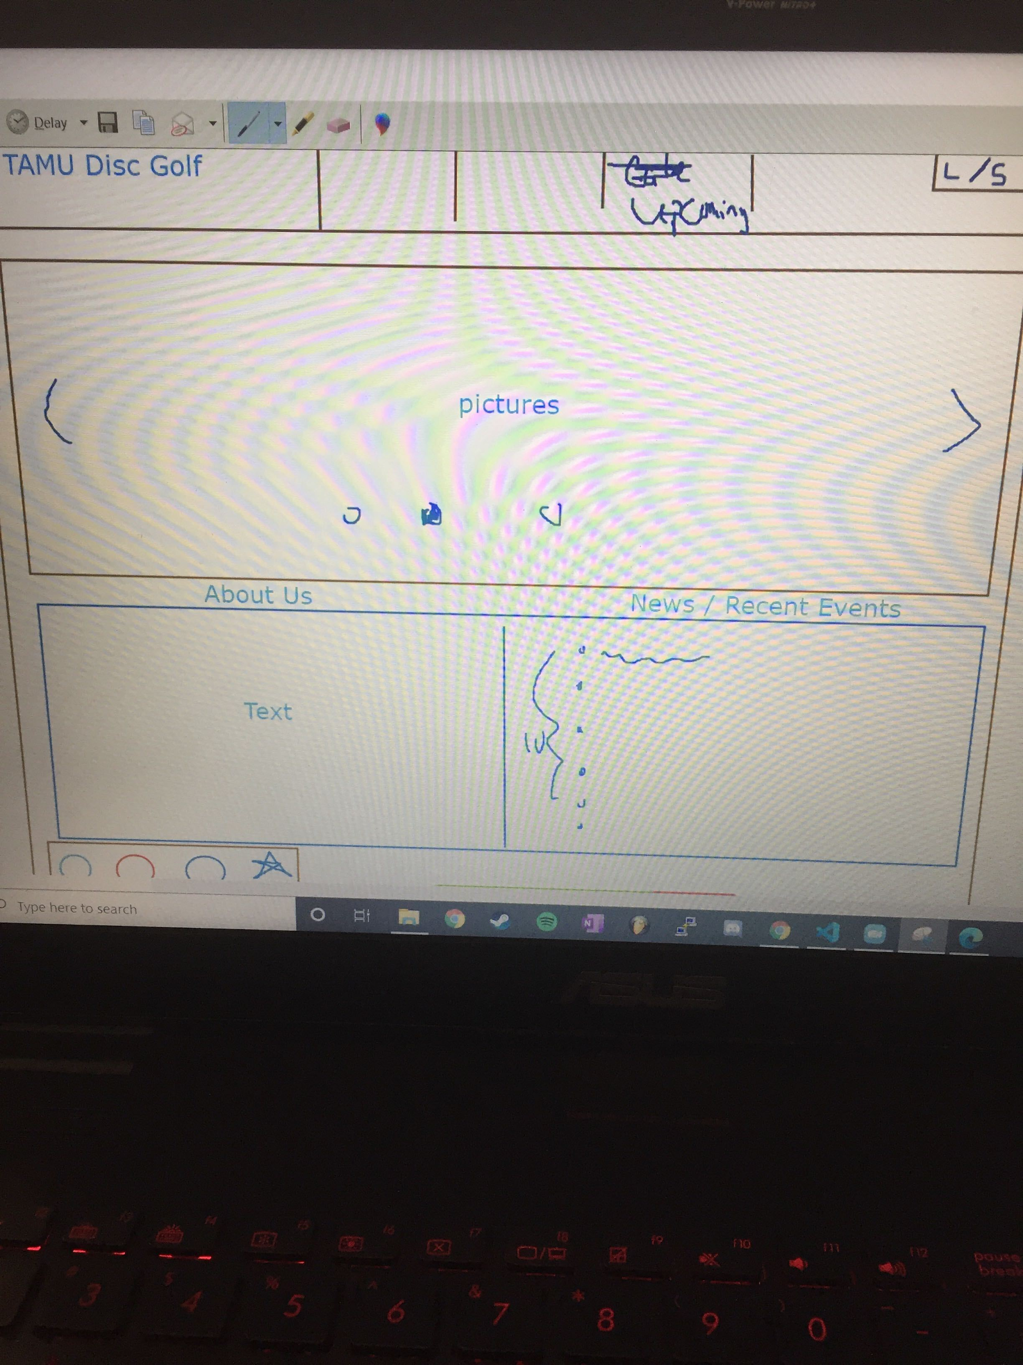

The image below is the redeveloped UI mock-up of the home page.



**Github Repo**

<https://github.com/acramer/tamu-disc-golf>

**Pivotal Tracker**

<https://www.pivotaltracker.com/n/projects/2467338>